A CASE STUDY ON STUDENT SATISFACTION WITH COLLEGE FACILITIES

*Report submitted to the*

SDM COLLEGE(Autonomous)



*In partial fulfillment of the degree of*

**MASTER OF SCIENCE**

**IN**

**STATISTICS**

*By*

*ANUSHA*

*MADHURA*

*NIDHISHA*

*PRADEEP*

*SHRAJAN KUMAR*

*SPOORTHI K*

Under the supervision of

**Ms. Shwetha Kumari**

**Department of Postgraduate Studies**

**in Statistics**

**SRI DHARMASTHALA MANJUNATHESHWARA**

**COLLEGE(Autonomous)**

**UJIRE-574240**

**SRI DHARMASTHALA MANJUNATHESHWARA COLLEGE (AUTONOMOUS) UJIRE-574240**



DEPARTMENT OF STATISTICS

**CERTIFICATE**

Certified that this is the bonafide record of project work done by during the year 2021 as a part of MSc (Statistics) first semester course work.

Reg.No:

|  |
| --- |
| 214001 |
| 214004 |
| 214006 |
| 214009 |
| 214012 |
| 214014 |

Project Guide: Head of Department

Examiners:

1.

2.

Place: Ujire

Date :

**ACKNOWLEDGEMENTS**

Firstly, I would like to thank our principal **Dr. P.N Udayachandra** and our Dean **Dr.Vishwanatha P** for the support. It is my pleasure to thank **Prof. Shanthi Prakash**, HOD of Statistics, for his support.

I would also like to thank **Ms. Shwetha Kumari,** Asst.Professor, Department of PG Statistics, SDM PG Centre, Ujire**, Dr.Savitha Rao**, Asst.Professor, Department of Statistics, SDM College, Ujire, **Ms.Supriya S.P**, Asst.Professor, Department of PG Statistics, SDM PG Centre, Ujire and **Mr. Pradeep**, Asst.Professor, Department of PG Statistics, SDM PG Centre, Ujire for their kind help, encouragement and support.

I am also thankful to all my family members and friends for their constant encouragement and help in each step.

My sincere thank also goes to the students of SDM College, Ujire, who have helped me directly or indirectly during my project work.

Finally to all who helped us in many ways, We say, ‘**Thank You!**’.

**Contents**

**1 Chapter 1**

**Introduction**

1.1 Introduction

1.2 Objectives

1.3 Scope of the Survey

**2 Chapter 2**

**Methodology**

2.1 Methods

2.2 About the data

2.3 Stratified random sampling

2.4 Statistical Techniques used for Data Analysis

2.4.1 Bar Chart

2.4.2 Pie Chart

2.4.3 Doughnut-Chart

2.4.4 Cluster-Chart

**3 Chapter 3**

**Results and Discussion**

**4 Chapter 4**

**Conclusion**

**5 Chapter 5**

**Bibliography**

**1 Chapter 1**

**Introduction**

* 1. **Introduction**

Students are the most important stake holders in the system of education. Quality and standard of educational system depends on the satisfaction of the students. It is needless to say any educational institution ought to measure the student’s satisfaction level by conducting survey every year and necessary steps are to be initiated and problems are to be addressed effectively. Society is always susceptible to mutability and demands changes in the educational system suiting to be needs and aspirations of the student varying time to time.

Nowadays, student’s opinions about all aspects of academic life are sought by educational institutions worldwide. University becomes a place to provide services to fulfill the student’s needs. Student’s demand is at a higher level not only in relation to the quality of teaching but also to the condition of facilities.Thus, a strategy of continuous improvement with regard to service quality is very important. Student’s satisfaction is the key to the success of educational institute. When we talk about the student’s satisfaction with their institute it refers to the student’s expectations from their institute. The more the university facilitates students by providing facilities that make their experience conductive and help them in attainment of necessary skills and abilities more the students satisfied. Student’s satisfaction has become an extremely important issue for universities and the management itself direct or indirectly. Hence, students’ satisfaction is an important issue in terms of quality of service provided in the marketing to be addressed by the university. University should focus the services to students because as a direct customer they receive the service directly from the university program. The objective of any university is to maximize students satisfaction maximize dissatisfaction and therefore this in turn to improve the institutions performance.The improvement of the services provided by university can be achieved by getting feedback, comments, complaints or objections from the students as a customer. From the positive or negative feedback, the university has a better view of the strengths and weaknesses of its services so that improvement can be made wherever necessary. This can be carried out continuously to gain better relationship to the students as a whole.

**1.3 Objectives**

* To know the quality of teaching in college.
* To find satisfactory level of students on cleanliness, infrastructure and water facilities in the college.
* To know the student’s opinion on new facilities required in the college.
* To determine the opinion of student on online course,wi-fi facilities provided by college.
* To find the opinion about teaching staff and their teaching method along with technology used by them.
* To determine the student’s satisfactory level about library usage and lab apparatus.
* To determine the student’s overall opinion about the college.

**1.4 Scope of the Survey**

The aim of the survey is to determine the student’s satisfaction on facilities provided by SDM PG Centre, Ujire.

By using the results of the survey college can improve certain facilities like quality of teaching,wi-fi,lab and water facilities.

**2 Chapter 2**

**Methodology**

**2.1 Methods**

To study the Satisfaction of student on college facilities out of 600 students selectedsamples is 286 which is taken as strata of the SDM PG center Ujire, the stratified random sampling technique was adopted for this study of different departments are taken as strata.

**2.2 About the Data**

Name: Name of the students

Roll number: Roll number of the student.

**2.3 Stratified random sampling:**

Stratified random sampling is a method of sampling that involves the division of apopulation into smaller groups-called strata.The groups or strata are organized based onthe shared characteristics or attributes of the members in the groups.The process ofclassification the population into groups is called satisfaction.

How Stratified Random Sampling Works:

When completing analysis or research on a group of entities with similar characteristics, a researcher may find that the population size is too large for which to complete research.To save time and money, an analyst may take on a more feasible approach by selecting asmall group from the population. The small group is referred to as a sample size, which is a subset of the population that isused to represent the entire population. A sample may be selected from a populationthrough a number of ways, one of which is the stratified random sampling method.

**2.4 Statistical Techniques used for Data Analysis**

Excel has been used to carry out the analysis of the data. The statistical methods

considered in order to carry out the analysis are given as follows:

**2.4.1 Bar Chart**

A bar chart or bar graph is a chart or graph that presents categorical data with rectangular bars with heights or lengths proportional to the values that they represent. The categorial data is a grouping of data into discrete groups. The bars cam be plotted vertically or horizontally. A vertical bar chart is sometimes called a column chart. In a bar chart categories appear along the horizontal axis and the height of the bar correspond to the value of each category.

**2.4.2 Pie Chart**

A pie chart is a statistical graphic, which is divided into slices to illustrate numerical proportion. Pie chart represents the data in a circular graph. The slices of pie show the relative size of the data and it is a type of pictorial

**2.4.3 Doughnut-Chart**

It is an improved version of Pie Charts to eliminate the trickiness of reading pie

charts. These charts are known to express the relationship of ‘part-to-whole’ where all partsrepresent 100% when collected together. It displays survey questions or data with a small number ofcomparing categories. They enable compact and simple representation as compared to pie charts.Furthermore the center hole can help display related information. You can use them in segments.

**2.3.4 Cluster-Chart**

Cluster-Chart is like bar chart except that it clusters several bars into a category and displays each cluster separately from the rest. For example, you couldcategorize quarterly sales data by each salesperson on your team,so each person has four bars: one of each quarter

**3 Chapter 3**

**Results and Discussion**

**Analysis of Data**

**3.1 Analysis on student satisfaction on quality of teaching**

Table representing opinion of students of different course on satisfaction of quality of teaching.

**1st Year:**

|  |  |  |  |  |  |  |  |  |  |  |  |
| --- | --- | --- | --- | --- | --- | --- | --- | --- | --- | --- | --- |
| M.SC | | | | M.COM | | | | MSW | | | |
| very good | good | Neutral | bad | very good | good | Neutral | bad | very good | good | Neutral | bad |
| 31 | 53 | 5 | 3 | 10 | 11 | 0 | 0 | 6 | 10 | 4 | 0 |

|  |  |  |  |  |  |  |  |
| --- | --- | --- | --- | --- | --- | --- | --- |
| MA | | | | MCJ | | | |
| very good | good | Neutral | bad | very good | good | Neutral | bad |
| 1 | 7 | 1 | 0 | 1 | 5 | 2 | 0 |

**Bar graph representing Quality of Teaching**

**Conclusion:** The bar graph represents 2nd year student’s opinion about the quality of teaching in the college. Except MCJ, opinion of students from all the disciplines is good. Opinion of MCJ students is neutral. Overall student’s opinion about the quality of teaching is good.

Table representing opinion of students of different course on satisfaction of quality of teaching.

**2nd year**

|  |  |  |  |  |  |  |  |  |  |  |  |
| --- | --- | --- | --- | --- | --- | --- | --- | --- | --- | --- | --- |
| MSC | | | | M.COM | | | | MSW | | | |
| very good | good | Neutral | bad | very good | good | Neutral | bad | very good | good | Neutral | bad |
| 20 | 46 | 12 | 0 | 6 | 16 | 1 | 0 | 1 | 8 | 5 | 0 |

|  |  |  |  |  |  |  |  |
| --- | --- | --- | --- | --- | --- | --- | --- |
| MA | | | | MCJ | | | |
| very good | good | Neutral | bad | very good | good | Neutral | bad |
| 0 | 7 | 1 | 0 | 2 | 2 | 5 | 2 |

**Bar graph representing Quality of Teaching:**

**Conclusion:** The bar graph represents 1st year student’s opinion about the quality of teaching in the college. Opinion of students from different disciplines regarding quality of teaching in the college is good. So overall we can say quality of teaching in the college is good.

**Overall Conclusion:** From 1st and 2nd year student’s opinion with different disciplines, we can conclude that quality of teaching in the college is good.

**3.2 Analysis on opinion of students on teaching staff and their teaching method:**

Table representing opinion of students of different course on teaching staff and teaching methods.

**1stYear:**

|  |  |  |  |  |  |  |  |  |
| --- | --- | --- | --- | --- | --- | --- | --- | --- |
|  | M.SC | | | | M.COM | | | |
|  | very good | good | Neutral | bad | very good | good | Neutral | bad |
| Opinion on teaching staff  and method | 22 | 48 | 8 | 0 | 6 | 16 | 1 | 0 |
| Opinion on technology used  by teaching faculty | 20 | 45 | 13 | 0 | 5 | 18 | 0 | 0 |

|  |  |  |  |  |  |  |  |  |  |  |  |
| --- | --- | --- | --- | --- | --- | --- | --- | --- | --- | --- | --- |
| MSW | | | | MA | | | | MCJ | | | |
| very good | good | Neutral | bad | very good | good | Neutral | bad | very good | good | Neutral | bad |
| 2 | 12 | 0 | 0 | 0 | 8 | 0 | 0 | 0 | 8 | 0 | 3 |
| 1 | 13 | 0 | 0 | 1 | 7 | 0 | 0 | 2 | 8 | 1 | 0 |

**Conclusion:** The bar graph shows 1st year Student’s opinion about teaching staff and technology used by the faculty. Opinion of students from different disciplines regarding teaching staff and technology used by the faculty is good. So overall we can say student’s opinion regarding teaching staff and technology used by the faculty is good.

Table representing opinion of students of different course on teaching staff and teaching methods.

**2nd Year:**

|  |  |  |  |  |  |  |  |  |
| --- | --- | --- | --- | --- | --- | --- | --- | --- |
|  | M.SC | | | | M.COM | | | |
|  | very good | good | Neutral | bad | very good | good | Neutral | Bad |
| Opinion on teaching staff  and method | 29 | 55 | 6 | 3 | 7 | 13 | 1 | 0 |
| Opinion on technology used  by teaching faculty | 28 | 57 | 8 | 0 | 9 | 12 | 0 | 0 |

|  |  |  |  |  |  |  |  |  |  |  |  |
| --- | --- | --- | --- | --- | --- | --- | --- | --- | --- | --- | --- |
| MSW | | | | MA | | | | MCJ | | | |
| very good | good | Neutral | bad | very good | good | Neutral | bad | very good | good | Neutral | bad |
| 9 | 11 | 0 | 0 | 2 | 7 | 0 | 0 | 0 | 8 | 0 | 0 |
| 8 | 6 | 6 | 0 | 1 | 7 | 1 | 0 | 0 | 6 | 2 | 0 |

**Conclusion:** The bar graph shows 1st year Student’s opinion about teaching staff and technology used by the faculty. Opinion of students from different disciplines regarding teaching staff and technology used by the faculty is good. Almost zero or very few student’sopinion is bad. So overall we can say student’s opinion regarding teaching staff and technology used by the faculty is good.

**Overall Conclusion**: From 1st and 2nd year student’s opinion, we can conclude that student’s opinion regarding teaching staff and technology used by the faculty is good.

**3.3 Analysis on opinion of students on the topics in subjects which are job oriented**

Table representing opinion of students of different course on the topics insyllabus which are job oriented.

**1st Year:**

|  |  |  |  |  |  |  |  |  |  |  |  |  |
| --- | --- | --- | --- | --- | --- | --- | --- | --- | --- | --- | --- | --- |
|  | M.SC | | | | M.COM | | | | MSW | | | |
| job oriented | <25% | 25%-50% | 50%-75% | 75%-100% | <25% | 25%-50% | 50%-75% | 75%-100% | <25% | 25%-50% | 50%-75% | 75%-100% |
| 0 | 13 | 61 | 15 | 0 | 5 | 15 | 0 | 1 | 2 | 8 | 6 |

|  |  |  |  |  |  |  |  |
| --- | --- | --- | --- | --- | --- | --- | --- |
| MA | | | | MCJ | | | |
| <25% | 25%-50% | 50%-75% | 75%-100% | <25% | 25%-50% | 50%-75% | 75%-100% |
| 0 | 3 | 5 | 0 | 0 | 2 | 0 | 0 |

Table representing opinion of students of different course on the topics in syllabus which are job oriented.

**2nd Year:**

|  |  |  |  |  |  |  |  |  |  |  |  |  |
| --- | --- | --- | --- | --- | --- | --- | --- | --- | --- | --- | --- | --- |
|  | M.SC | | | | M.COM | | | | MSW | | | |
| Job oriented | <25% | 25%-50% | 50%-75% | 75%-100% | <25% | 25%-50% | 50%-75% | 75%-100% | <25% | 25%-50% | 50%-75% | 75%-100% |
| 6 | 25 | 32 | 9 | 1 | 6 | 13 | 2 | 2 | 7 | 1 | 1 |

|  |  |  |  |  |  |  |  |
| --- | --- | --- | --- | --- | --- | --- | --- |
| MA | | | | MCJ | | | |
| <25% | 25%-50% | 50%-75% | 75%-100% | <25% | 25%-50% | 50%-75% | 75%-100% |
| 0 | 1 | 7 | 0 | 1 | 5 | 1 | 0 |

**THE PIE CHART REPRESENTS THE SATISIFACTION OF STUDENT ON TOPICS IN SUBJECT (%)**

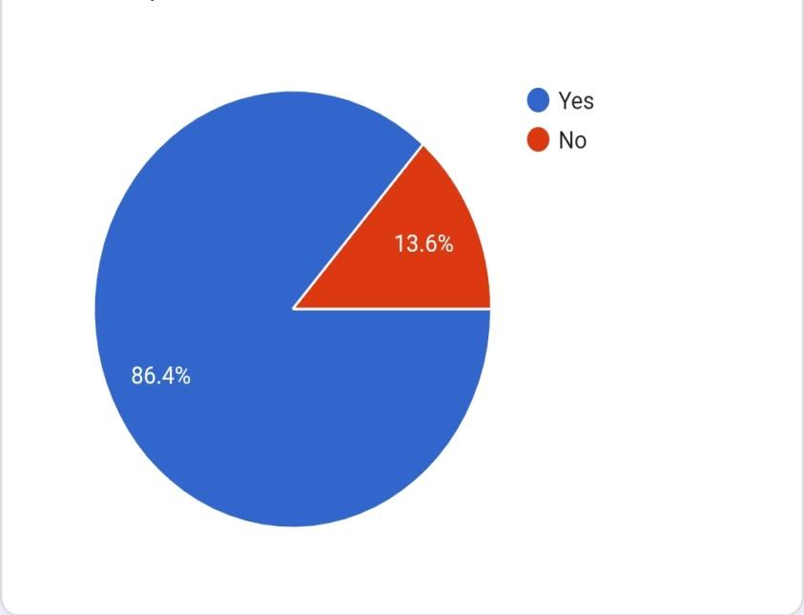

**THIS BAR GRAPHS REPRESENTS THE TOPICS IN SYLLABUS IS JOB ORIENTED (%)**

**Conclusion:** The above cluster chart shows the opinion of first year and second year student of M.sc about topics in syllabus is job oriented. M.sc student given their opinion that 50%-75% of topics in syllabus are job oriented and very few numbers of students given that topics in syllabus are job oriented.

**Conclusion:** The above cluster chart shows the opinion of first year and second year student of M.com about topics in syllabus is job oriented. First year and second year of M.com student given their opinion that 50%-75% of topics in syllabus are job oriented and vary few numbers of students given that topics in syllabus are job oriented.

**Conclusion:** The above cluster chart shows the opinion of first year and second year student of MSW about topics in syllabus is job oriented. First year of MSW student given their opinion that 25%-50% of topics in syllabus are job oriented. Second year MSW student given that 50%-75% of topics in syllabus are job oriented.

**Conclusion:** The above cluster chart shows the opinion of first year and second year student of MA about topics in syllabus is job oriented. Both first and second year MA students given their opinion that 50%-75% of topics in syllabus are job oriented.

**Conclusion:** The above cluster chart shows the opinion of first year and second year student of MSW about topics in syllabus is job oriented. First year MCJ student given their opinion that 50%-75% of topics in syllabus are job oriented. Second year MCJ student given that 25%-50% of topics in syllabus are job oriented.

**OVERALL CONCLUSION:** Opinion of first year student from different disciplines, we conclude that 50%-75% of topics in syllabus are job oriented and from opinion of second year student except MSW and MCJ student, we conclude that 50%-75% of topics in syllabus are job oriented

**3.4 Analysis on student satisfaction on online course provided by the college.**

Table representing opinion of students of different course on online course provided by college

**1st Year:**

|  |  |  |  |  |  |  |  |  |
| --- | --- | --- | --- | --- | --- | --- | --- | --- |
|  | M.SC | | | | M.COM | | | |
| Satisfaction on online course | <25% | 25%-50% | 50%-75% | 75%-100% | <25% | 25%-50% | 50%-75% | 75%-100% |
| 2 | 24 | 53 | 14 | 0 | 2 | 19 | 0 |

|  |  |  |  |  |  |  |  |  |  |  |  |  |  |
| --- | --- | --- | --- | --- | --- | --- | --- | --- | --- | --- | --- | --- | --- |
| MSW | | | | MA | | | | MCJ | | | | | |
| <25% | 25%-50% | 50%-75% | 75%-100% | <25% | 25%-50% | 50%-75% | 75%-100% | <25% | 25%-50% | 50%-75% | | 75%-100% | |
| 3 | 8 | 5 | 4 | 0 | 0 | 7 | 2 | 0 | 2 | | 3 | | 3 |

**Doughnut Chart representing Satisfaction on Online Courses:**

**Conclusion:** Dough-Nut chart represents 1st year student’s satisfaction on online courses. Students from MSc, M.Com, MA, MCJ are satisfied with the online courses provided by college. So overall we can say that Except MSW, all the students are satisfied with the online courses provided by college.

Table representing opinion of students of different course on online course provided by college

**2nd Year:**

|  |  |  |  |  |  |  |  |  |
| --- | --- | --- | --- | --- | --- | --- | --- | --- |
|  | M.SC | | | | M.COM | | | |
| Satisfaction on online course | <25% | 25%-50% | 50%-75% | 75%-100% | <25% | 25%-50% | 50%-75% | 75%-100% |
| 2 | 24 | 53 | 14 | 0 | 2 | 19 | 0 |

|  |  |  |  |  |  |  |  |  |  |  |  |
| --- | --- | --- | --- | --- | --- | --- | --- | --- | --- | --- | --- |
| MSW | | | | MA | | | | MCJ | | | |
| <25% | 25%-50% | 50%-75% | 75%-100% | <25% | 25%-50% | 50%-75% | 75%-100% | <25% | 25%-50% | 50%-75% | 75%-100% |
| 3 | 8 | 5 | 4 | 0 | 0 | 7 | 2 | 0 | 2 | 3 | 3 |

**Doughnut Chart representing Satisfaction on Online Courses:**

**Conclusion:** Dough-Nut chart represents 2nd year student’s satisfaction on online courses. Students with different disciplines are satisfied with the online courses provided by college. So overall we can say that all the students are satisfied with the online courses provided by college.

**Overall Conclusion:** From 1st and 2nd year student’s opinion we can conclude that students of all the disciplines are satisfied with the online courses provide by college.

**3.5 Analysis on availability of books in library**

Table representing opinion of students of different course on availability of books in library.

**1st Year:**

|  |  |  |  |  |  |  |  |  |  |  |  |  |  |  |  |
| --- | --- | --- | --- | --- | --- | --- | --- | --- | --- | --- | --- | --- | --- | --- | --- |
|  | M.SC | | | M.COM | | | MSW | | | MA | | | MCJ | | |
| book in library | yes | no | unsure | yes | no | unsure | yes | no | unsure | yes | no | unsure | yes | no | unsure |
| 72 | 8 | 18 | 19 | 0 | 2 | 14 | 1 | 5 | 8 | 0 | 1 | 1 | 7 | 0 |

**BAR GRAPH REPRESENTS THE AVAILABILITY OF BOOK IN LIBRARY**

**Conclusion:** Bar graph represents 1st year student’s opinion about the availability of books in the library.According to MSC, M.Com,MSW,MA students, there are availability of books to refer in the library.

Table representing opinion of students of different course on availability of books in library.

**2nd Year:**

|  |  |  |  |  |  |  |  |  |  |  |  |  |  |  |  |
| --- | --- | --- | --- | --- | --- | --- | --- | --- | --- | --- | --- | --- | --- | --- | --- |
|  | M.SC | | | M.COM | | | MSW | | | MA | | | MCJ | | |
| book in library | yes | no | unsure | yes | no | unsure | yes | no | unsure | yes | no | unsure | yes | no | unsure |
| 53 | 19 | 16 | 15 | 1 | 7 | 5 | 5 | 4 | 7 | 1 | 0 | 4 | 5 | 2 |

**BAR GRAPH REPRESENTS THE AVAILABILITY OF BOOK IN LIBRARY**

**Conclusion:** Bar graph represents 2nd year student’s opinion about the availability of books in the library. According to MSC,M.Com, MA students there are availability of books to refer in the library. But opinion of students from MSW and MCJ is that there isn’t availability of books in the library.

**Overall conclusion:** From 1st and 2nd year student’s opinion with different disciplines is that there is availability of books to refer in the library.

**3.6 Analysis on college having proper lab apparatus**

Table representing opinion of students of different course on college having proper lab apparatus.

**1st year**

|  |  |  |  |  |  |  |  |  |  |  |  |  |  |  |  |
| --- | --- | --- | --- | --- | --- | --- | --- | --- | --- | --- | --- | --- | --- | --- | --- |
|  | M.SC | | | M.COM | | | MSW | | | MA | | | MCJ | | |
| proper lab apparatus | yes | no | unsure | yes | no | unsure | yes | no | unsure | yes | no | unsure | yes | no | unsure |
| 78 | 5 | 10 | 3 | 0 | 18 | 8 | 0 | 12 | 4 | 0 | 4 | 2 | 0 | 6 |

**Conclusion:** The bar graph represents 1st year student’s opinion about the proper lab apparatus in the college.Most of the student’s opinion is that the college has proper lab apparatus.

Table representing opinion of students of different course on college having proper lab apparatus.

**2nd year**

|  |  |  |  |  |  |  |  |  |  |  |  |  |  |  |  |
| --- | --- | --- | --- | --- | --- | --- | --- | --- | --- | --- | --- | --- | --- | --- | --- |
|  | M.SC | | | M.COM | | | MSW | | | MA | | | MCJ | | |
| proper lab appartus | yes | no | unsure | yes | no | unsure | yes | no | unsure | yes | no | unsure | yes | no | unsure |
| 55 | 8 | 14 | 5 | 0 | 18 | 2 | 1 | 11 | 2 | 0 | 6 | 0 | 2 | 9 |

**Conclusion:** The bar graph represents 2nd year student’s opinion about the proper lab apparatus in the college. Most of the student’s opinion is that the college has proper lab apparatus.

**3.7 Analysis on proper Wi-fi facilities in the college**

**Pie Chart representing Proper Wi-fi Facilities:**

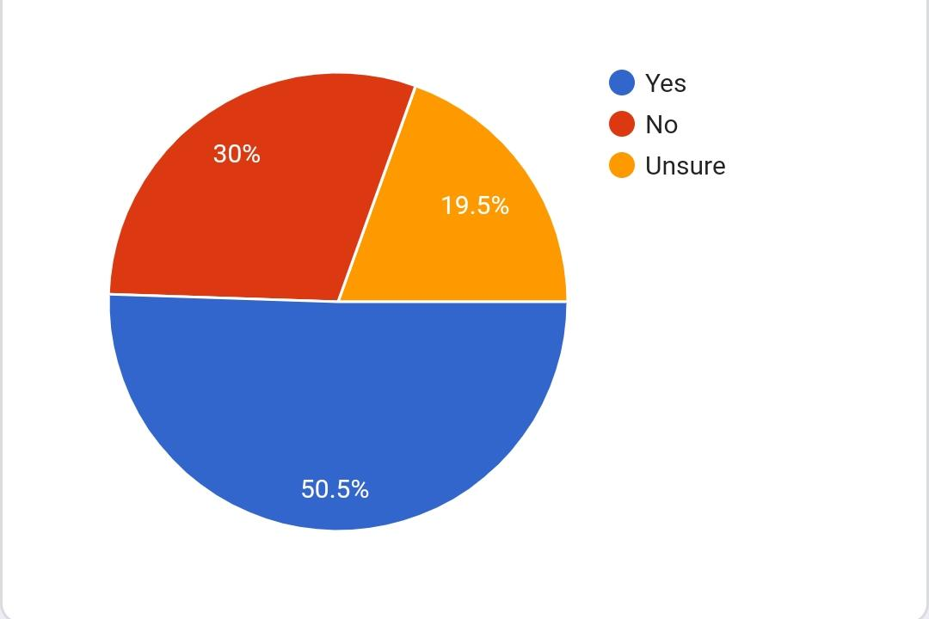

**Conclusion:** The pie chart shows the student’s opinion about the proper wi-fi facilities in the college. Almost half of the student’s opinion is that the college has proper Wi-Fi facilities. 19.5% of the students are unsure about this. About 30% of the student’s opinion is that college doesn’t have proper wi-fi facilities. So overall we can conclude that the college has proper Wi-fi facilities.

**3.8 Analysis on extracurricular activities in the college**

**Pie Chart representing Extra Curricular Activities in the College:**

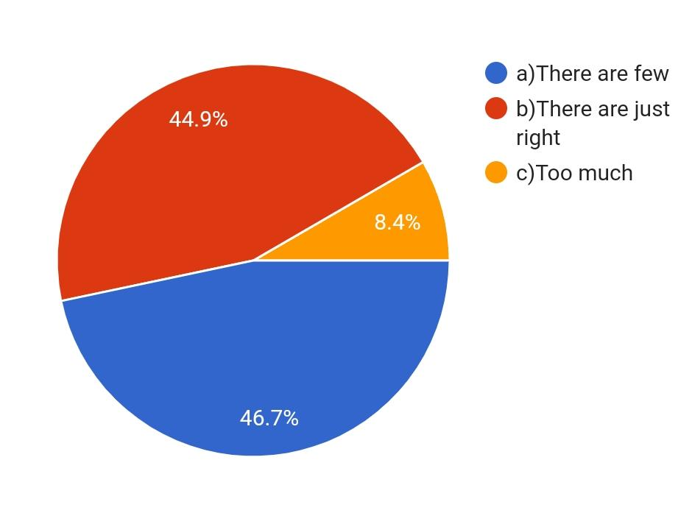

**Conclusion:** The pie chart shows 46.7% of the student’s opinion about extracurricular activities in the college is few and 44.9% of the student’s opinion is there are just right. Only 8.4% of the student’s opinion is that there are too much.

**3.9 Analysis on cleanliness maintained in the college**

**Pie Chart representing Cleanliness in the College:**

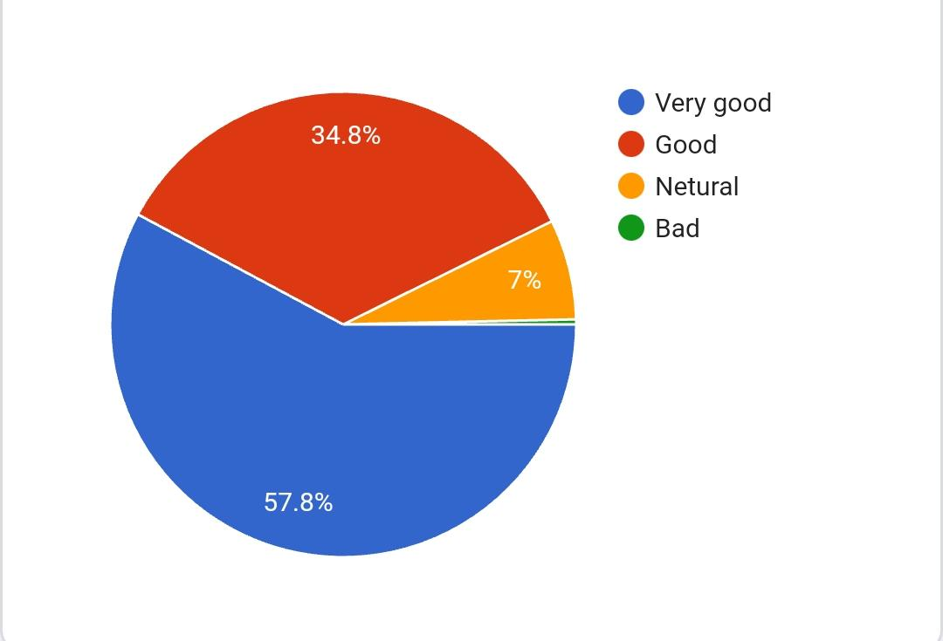

**Conclusion:** The pie chart depicts that 57.8% of the student’s opinion about the college cleanliness is very good. About 34.8% of the student’s opinion is good. Only 7% of the student’s opinion is neutral. So overall we can conclude that most of the student’s opinion regarding the cleanliness in the college is good. This shows that the college is well maintained and clean.

**3.10 Analysis on water facilities in the college**

**Pie Chart representing Water Facilities in the College:**

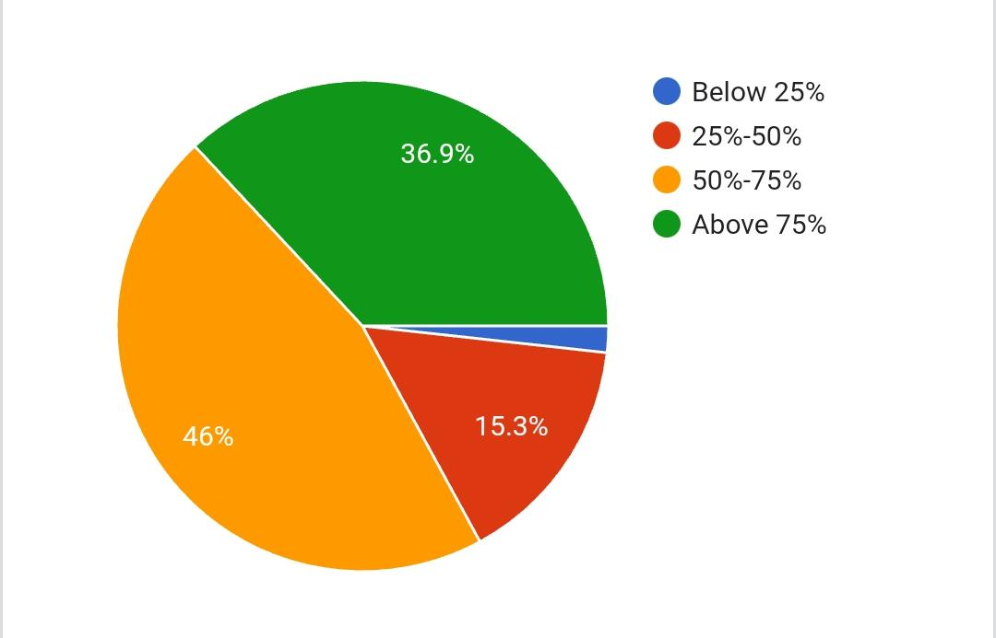

**Conclusion:** The pie chart represents the student’s satisfaction level about the water facilities in the college. 46% of the student’s satisfaction level about the Water facilities in the college is almost about 50-75 %.36.9% of the student’s satisfaction level is above75%. This shows that the water facility in the college is quite good and most of the students are satisfied with the water facilities in the college.

**3.11 Analysis on new facilities to be required in the college**

**Bar graph representing new facilities required:**

|  |  |  |  |  |
| --- | --- | --- | --- | --- |
| New facilities | Canteen | Cooperative store | Xerox Centre | Others |
| 46.50% | 22.72% | 27.97% | 2.79% |

**Conclusion:** The bar graph represents student’s opinion about new facilities required in the college. 46% of the students require Canteen in the college. About 23% of the students need Cooperative store.28% of the students require Xerox centre in the college. So overall we can say students require canteen in the college.

**3.12 Analysis on opinion of students on the infrastructure of the college**

**Pie Chart representing student’s satisfaction on infrastructure of the college:**

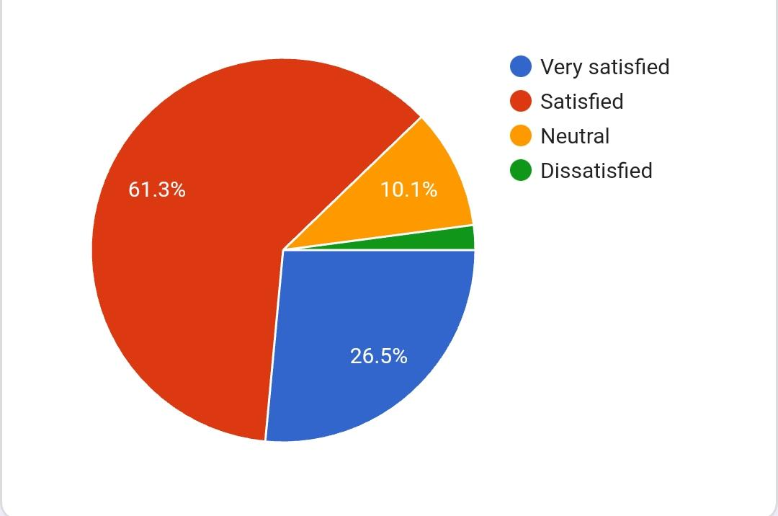

**Conclusion:** The pie chart represents satisfaction level of students regarding infrastructure of the college. It shows that the about 61.3% of the students are satisfied with the infrastructure of the college. Nearly 10% of the student’s opinion is neutral. Only 2% of the students are dissatisfied with the infrastructure of the college. So overall we can conclude that most of the students are satisfied with the infrastructure of the college.

Table representing opinion of students of different course on over all opinion of students on college facilities.

**1st and 2nd Year:**

|  |  |  |  |  |
| --- | --- | --- | --- | --- |
| overall opinion | very good | good | Neutral | bad |
| 30.09% | 59.05% | 10.98% | 0% |

**Conclusion**: The bar graph represents student’s overall opinion about the college. 30% of the student’s overall opinion about the college is good. 59% of the student’s opinion about the college is good. Only 11% of the student’s overall opinion about the college is neutral. So from this we can conclude that student’s overall opinion regarding the college facilities is good.

**4 Chapter 4**

Conclusion

Following are the overall conclusions,

* Teaching staff and technology used by the faculty in SDM PG centre is good.
* Cleanliness in college is very good, and students are satisfied with infrastructure and water facilities in the college.
* Students suggested to have canteen and xerox center inside the campus.
* Students are well satisfied with online courses and wi-fi facilities provided by the college.
* Teaching staff, their teaching method and technology used by them are good.
* There is good availability of books to refer in the library for all discipline and college has proper lab apparatus.
* Overall, students have good opinion about college.

**5 Chapter 5**

**Bibliography**

* <https://www.google.co.in/>
* <https://www.tutoriaspoint.com/excel_charts_types.html>
* <https://www.statisticshowto.com>